Software Engineering Lab Task 3

11-12-2024

Eshwar Deshmukh Chavan

HU22CSEN0100999

**What is JIRA?**

JIRA is a widely-used project management and issue-tracking tool developed by Atlassian. It's particularly popular in software development but is also used in various other industries to organize and manage tasks, projects, and workflows. Here’s a detailed yet simple overview of its key features:

**Key Features of JIRA:**

1. Issue Tracking:
   * Task Management: JIRA allows you to create, assign, and monitor tasks or issues. This helps in keeping track of who is responsible for what and the status of each task.
   * Issue Types: Common issue types include bugs (problems in the software), stories (user requirements), tasks (general to-dos), and epics (large bodies of work that can be broken down into smaller tasks).
2. Project Management:
   * Agile Support: JIRA supports Agile methodologies like Scrum and Kanban, which are popular frameworks for managing software development projects.
   * Management Tools: It provides tools like boards (visual representations of work), sprints (time-boxed periods for completing work), and backlogs (lists of tasks to be done) to manage projects efficiently.
3. Customizable Workflows:
   * Tailored Processes: Users can define workflows that are tailored to their specific processes. This means you can set up different stages for tasks, such as "To Do," "In Progress," and "Done."
   * Flexibility: This customization allows teams to adapt JIRA to their unique workflows rather than the other way around.
4. Collaboration:
   * Team Communication: JIRA facilitates team collaboration with features like comments, mentions, and notifications. This ensures that everyone is on the same page and can easily communicate about tasks.
   * Integrations: It integrates with other collaboration tools like Slack, Microsoft Teams, and Confluence, making it easier to keep all project-related communications in one place.
5. Reporting:
   * Detailed Reports: JIRA offers detailed reports and dashboards, such as burndown charts (showing remaining work over time), velocity charts (showing the amount of work completed in each sprint), and cycle time reports (showing how long tasks take to complete).
   * Insights: These reports provide valuable insights into project progress and help in making data-driven decisions.
6. Integrations:
   * Tool Compatibility: JIRA integrates with a wide range of tools, including CI/CD pipelines (for automating the software development process), version control systems (like Git), and testing tools. This ensures a seamless workflow across different stages of the project.
7. Scalability:
   * Versatility: JIRA is suitable for small teams as well as large enterprises. It provides features for managing multiple projects and teams under a single platform.
   * Growth Support: As your team or projects grow, JIRA can scale with you, ensuring that you don’t need to switch tools as your needs change.

**Starting with “JIRA”:**

Step 1: Go JIRA site and link on sign up with google if new user or else sign in.

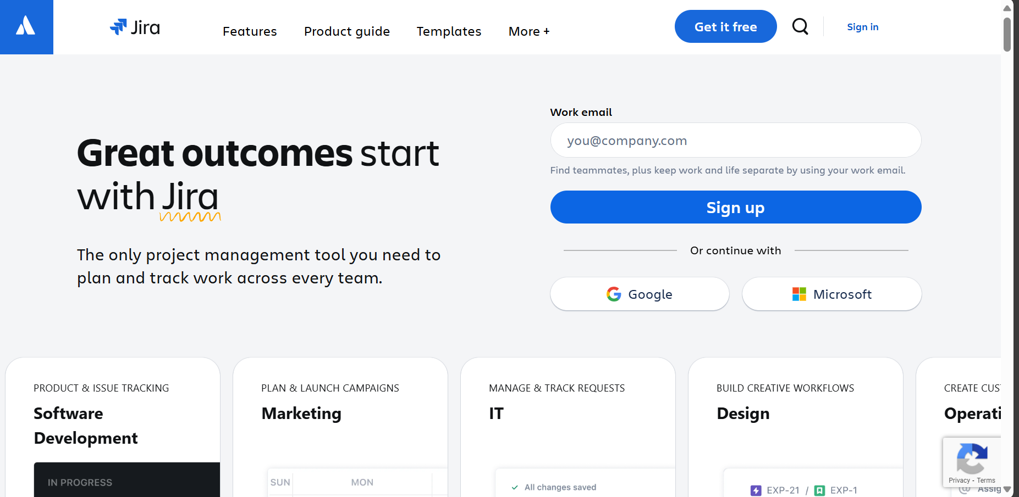

Step 2:Click on create your account

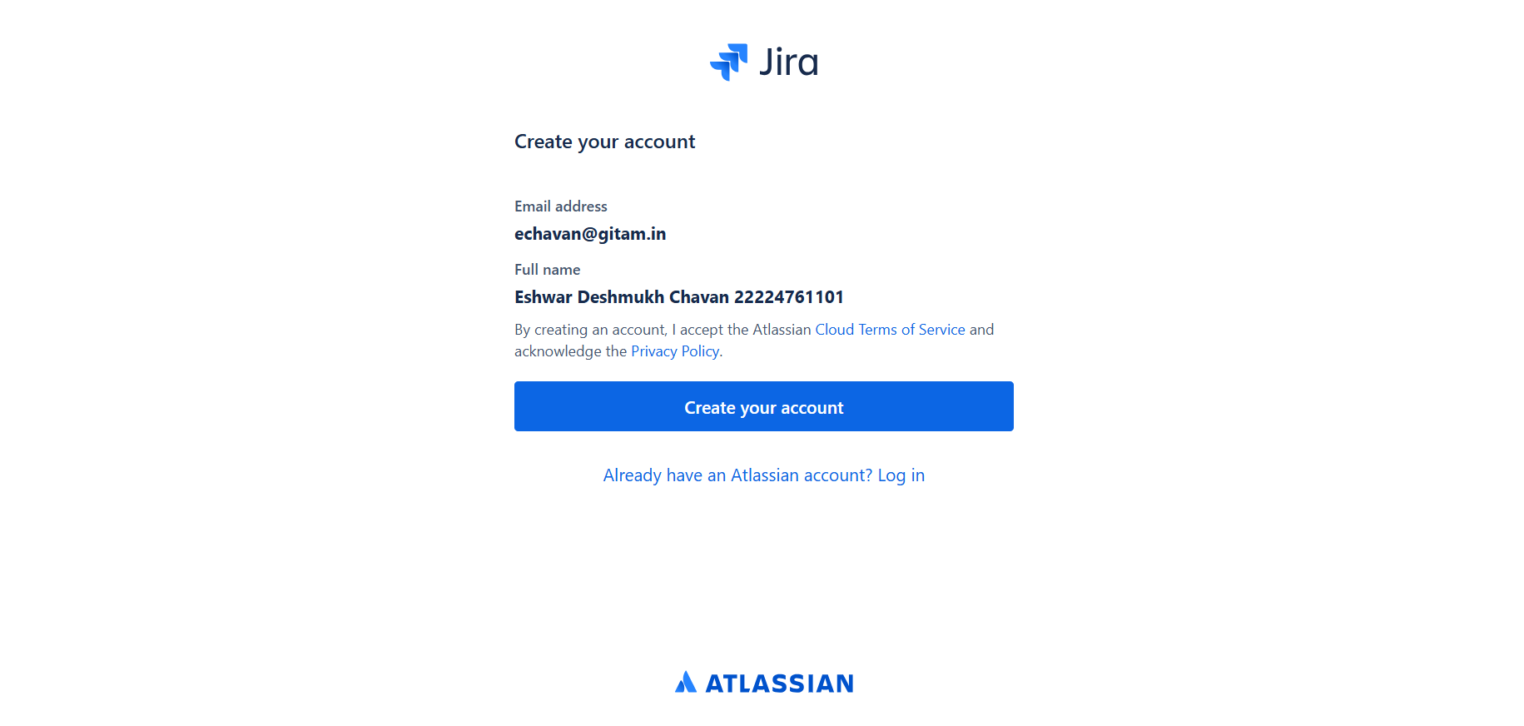

Step 3: Name your Site and click on continue.

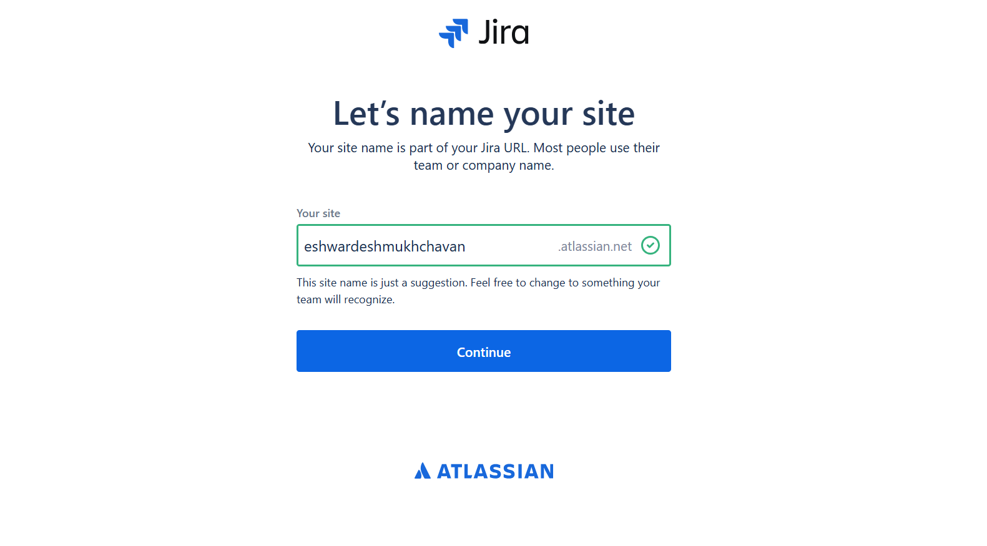

Step 4:Click on the work you do

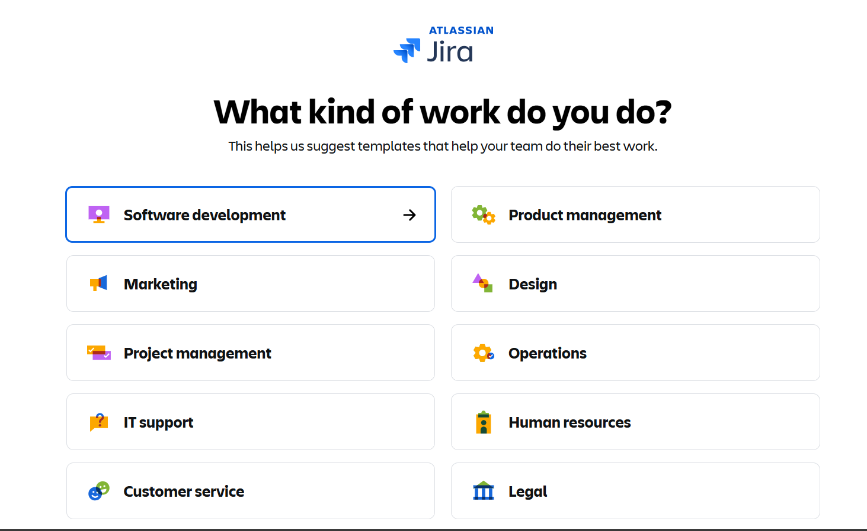

Step 5: Click on option in the team plan to use JIRA and continue.

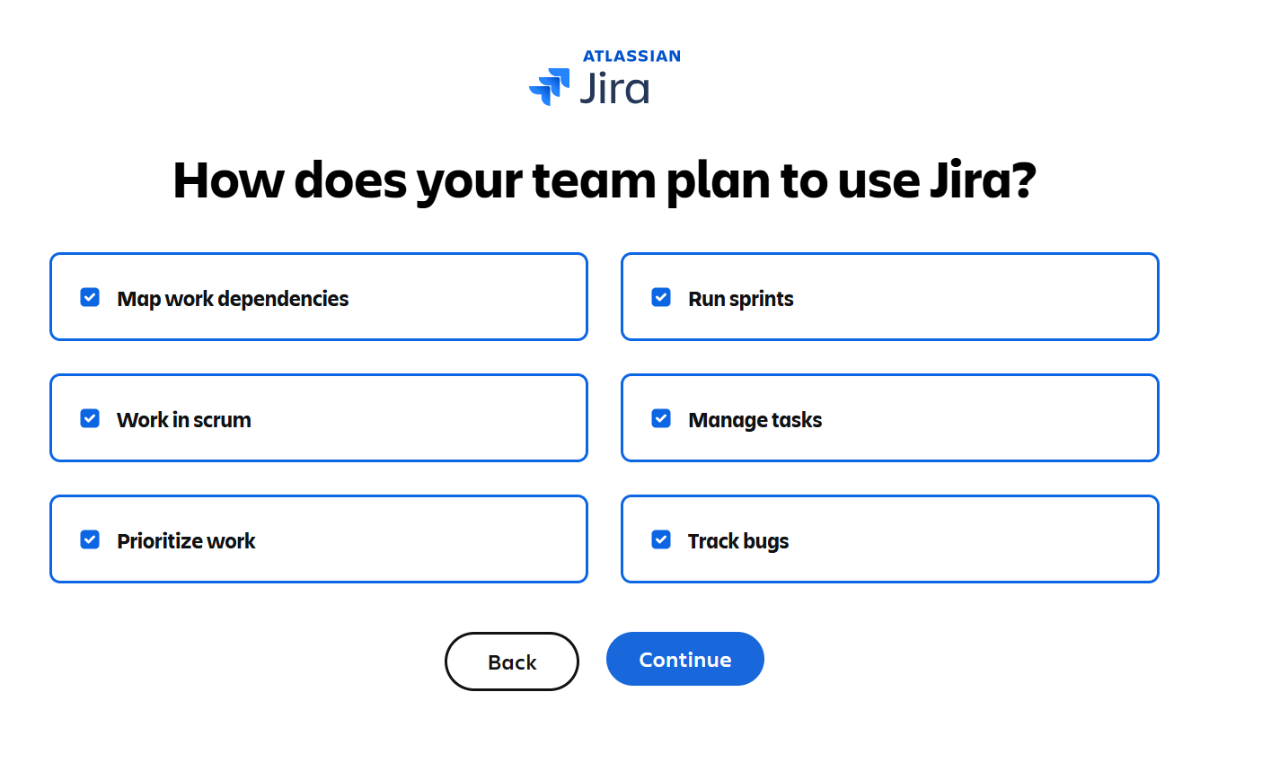

Step 6:Enter your project name and click on option how familiar are you with JIRA and get started.

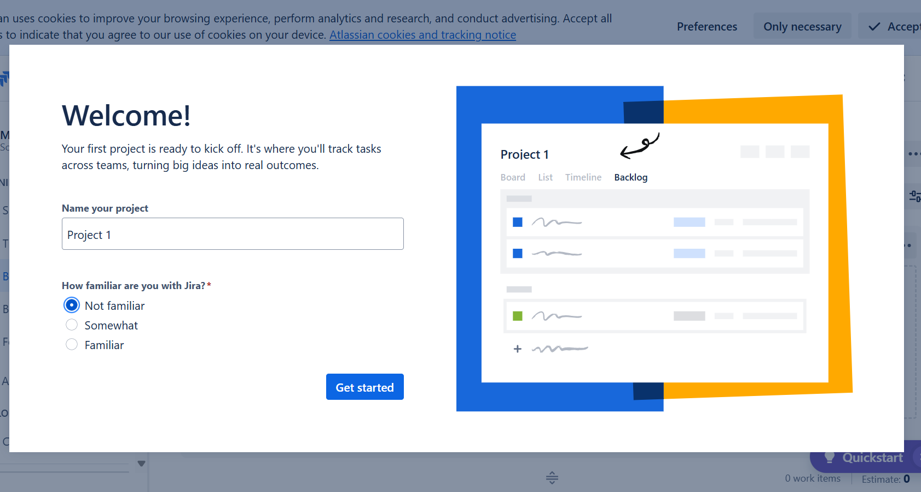

Step 7: Create Issue in JIRA and click on create.

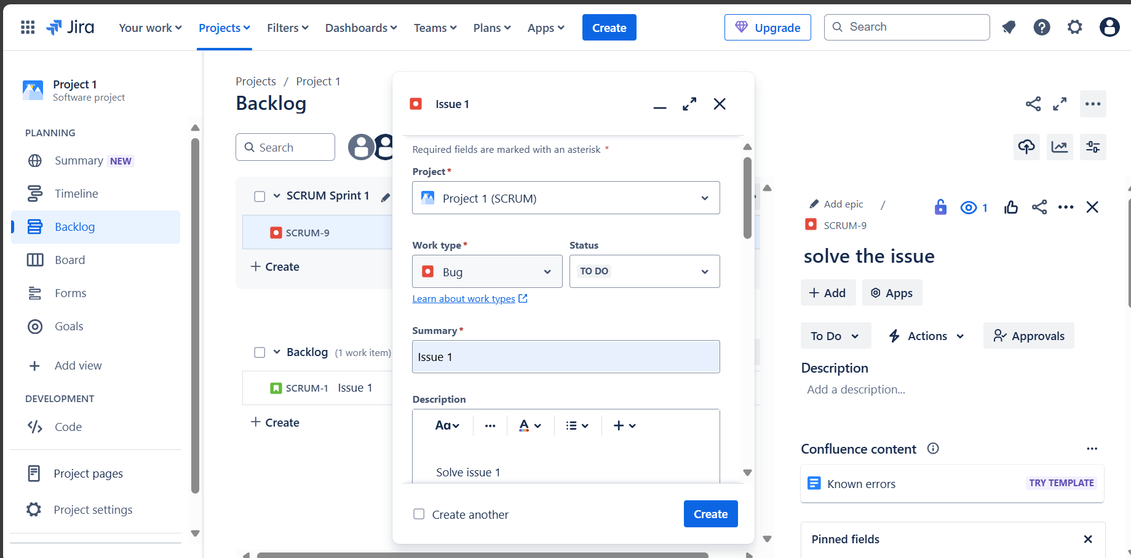

Step 8:Add task to your timeline.

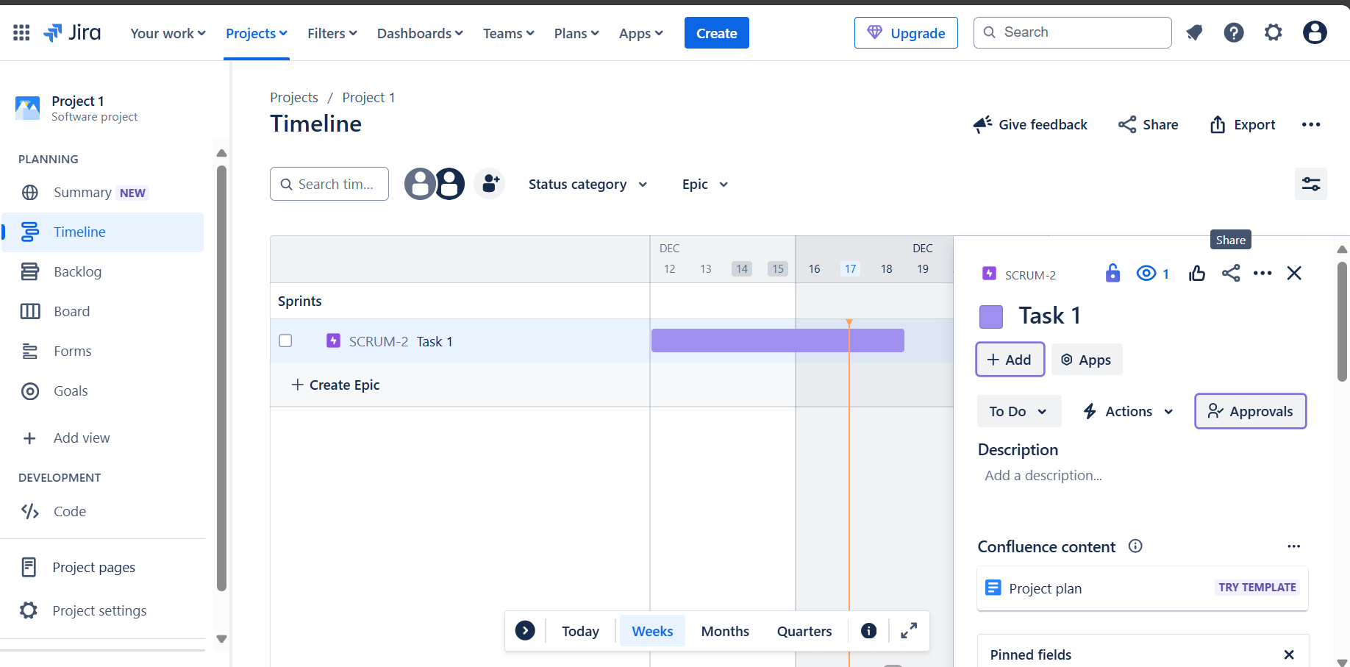

Step 9: Add multiple task to your timeline and change the color in the timeline.

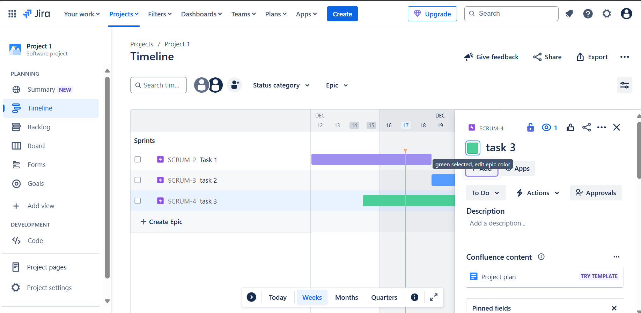

Step 10: Adding all your work in the timeline.

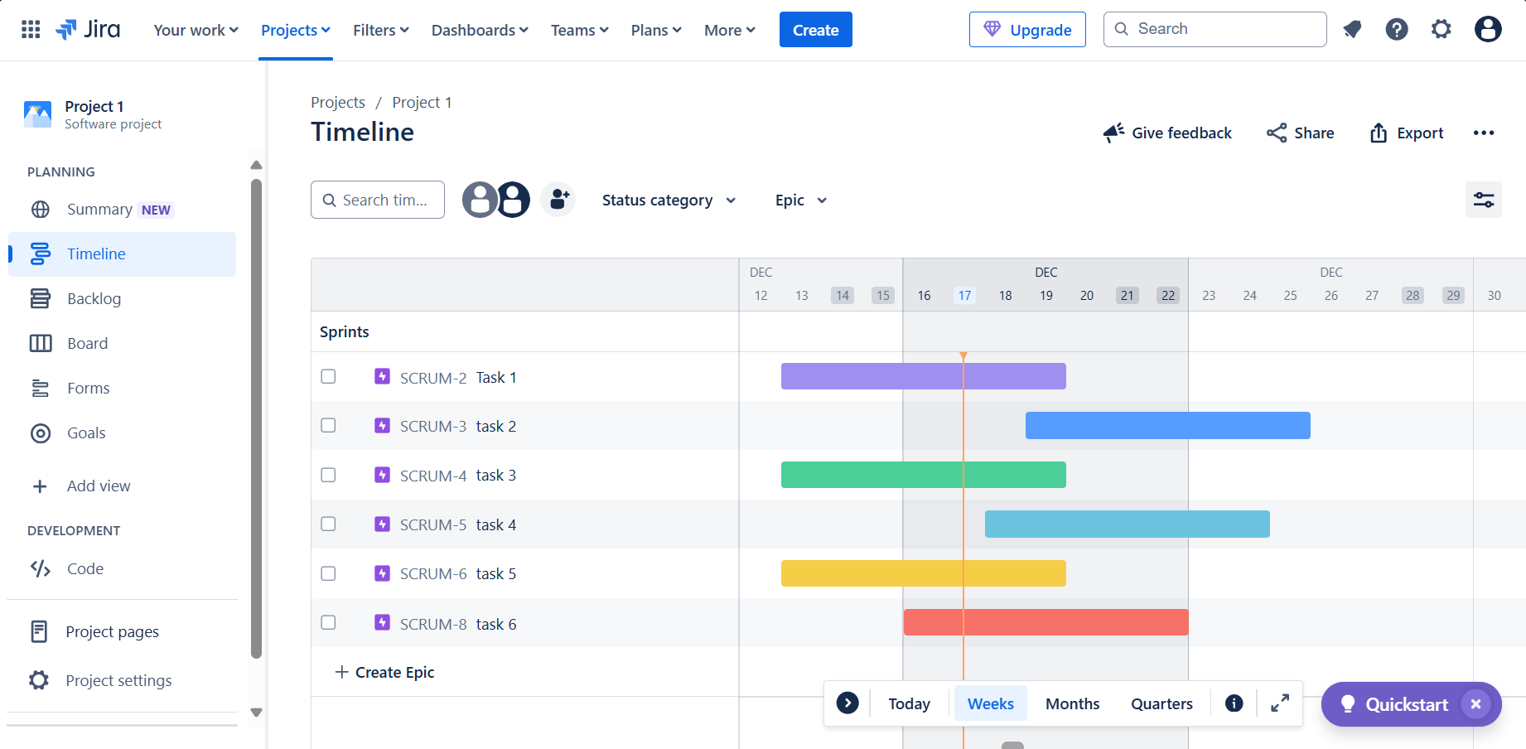

Step 11: Summary of the Project.

